Logisches Modell - Warehouse Management System

Benutzer (eMail)

Lager (LID, Name, Adresse)

Regal (RID, MaxEbene, LID)

Foreign Key: LID - References: Lager

Ebene (EID, RID)

Foreign Key 1: RID - References: Regal

Produkt (PID, Name, Menge, PreisProEinheit, EID)

Foreign Key 1: EID - References: Ebene

Einlagern (am, Menge, Preis, eMail, PID)

Foreign Key 1: eMail - References: Benutzer

Foreign Key 2: PID - References: Produkt

Auslagern (am, Menge, Preis, eMail, PID)

Foreign Key 1: eMail - References: Benutzer

Foreign Key 2: PID - References: Produkt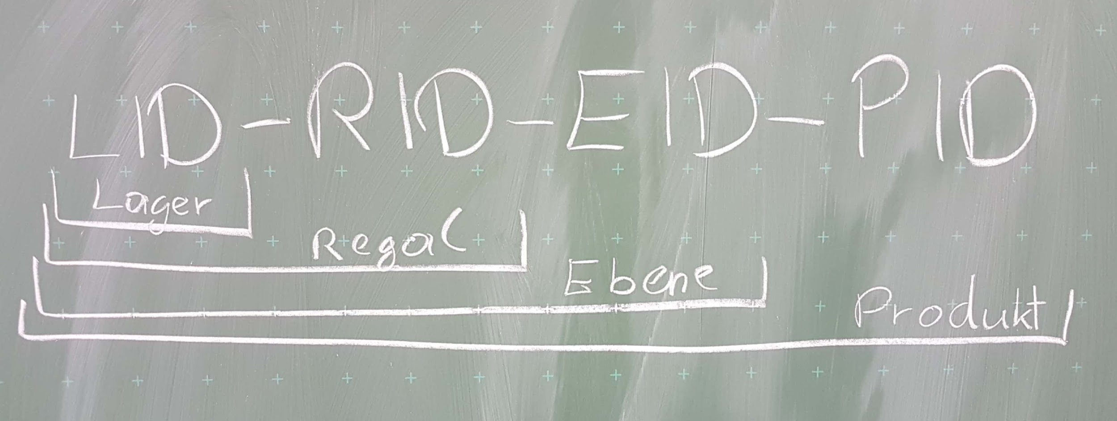

Create Tables - Warehouse Management System

drop table Benutzer cascade constraints;

drop table Lager cascade constraints;

drop table Regal cascade constraints;

drop table Ebene cascade constraints;

drop table Produkt cascade constraints;

drop table Einlagern cascade constraints;

drop table Auslagern cascade constraints;

create table Benutzer (

eMail varchar2(20)primary key

);

create table Lager (

LID varchar2(40) primary key,

Name varchar2(40),

Adresse varchar2(40)

);

create table Regal (

RID varchar2(40),

MaxEbene int,

RLID varchar2(40),

Foreign Key (RLID) References Lager (LID) on delete cascade,

Primary Key (RID)

);

create table Ebene (

EID varchar2(40),

ERID varchar2(40),

Primary Key (EID),

Foreign Key (ERID) REFERENCES Regal (RID)

);

create table Produkt (

PID varchar2(40),

Name varchar2(10),

Menge int,

PreisProEinheit int,

PEID varchar2(10),

primary key(PID),

foreign key (PEID) References Ebene (EID)

);

create table Einlagern (am date, Menge int, Preis int, eMail varchar2(20), PID varchar2(10),

Primary key (am, eMail, PID),

Foreign Key (eMail) References Benutzer (eMail),

Foreign key (PID) References Produkt(PID)

);

create table Auslagern (am date, Menge int, Preis int, eMail varchar2(20), PID varchar2(10),

Primary key (am, eMail, PID),

Foreign Key (eMail) References Benutzer (eMail),

Foreign key (PID) References Produkt(PID)

);

-- Beispiel Input

INSERT INTO Lager VALUES ('L1', 'Hauptlager', 'Tschinowitscherweg 5');

INSERT INTO Regal VALUES ('L1-R1', 4, 'L1');

INSERT INTO Ebene VALUES ('L1-R1-E1', 'L1-R1');

INSERT INTO Produkt VALUES ('L1-R1-E1-P1', 'Seide', 10, 2, 'L1-R1-E1');

INSERT INTO Produkt VALUES ('L1-R1-E1-P2', 'Baumwolle', 4, 1, 'L1-R1-E1');

INSERT INTO Produkt VALUES ('L1-R1-E1-P3', 'Polyester', 6, 3, 'L1-R1-E1');

commit;